L02: Activity Reflection (Learning Journal)
After completing the activity, fill in the table below.
Instructions
- Choose two features from your website
(for example: navbar, grid, card, or any bootstrap feature).
- Copy 3–6 lines of code related to that feature.
- Write 1–2 sentences explaining what the code does.
Feature Used  Navbar / Grid / Card / any bootstrap feature | AI Prompt Used  Write the prompt you used | Code Generated by AI  Screenshot a small section of the code related to the feature | What I Modified  Describe what you changed | What This Code Does  Explain what the code does
Example:  Card | Generate a Bootstrap card with image, product name and price | 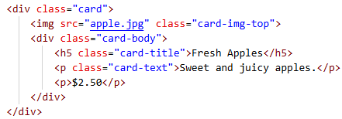 | Changed the product name, description and price | Displays a product card with an image, product description and price
Card | Create a responsive product grid using Bootstrap row and col classes | 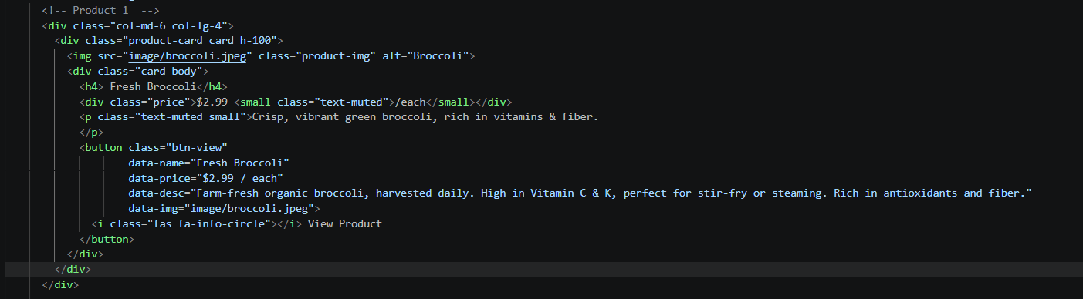 | Changed the product names, prices, images, and descriptions to match my 6 vegetable products | This part create a grid layout that adjust the number of products shown per row.  On tablet (col-md-6) will show 2 products per row.  On desktop screens (col-lg-4) will show 3 products per row.
Popup | Create a modal popup that shows product image, price, description and an Add to Cart button when user clicks View Product | 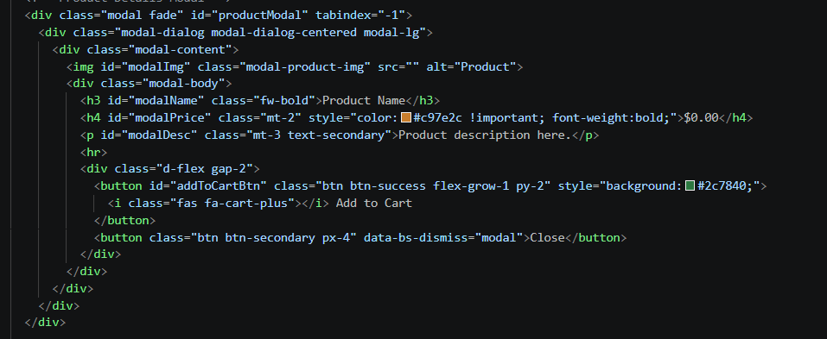 | Changed the modal image size and adjust button color to match the theme and customized the toast notification message | When the user click the button the modal popup appear on top of the page and showing the product image wit full description, price and “add to cart” button. User can close it without leaving the current page
Notification | Add a toast notification that appears when user adds an item to cart | 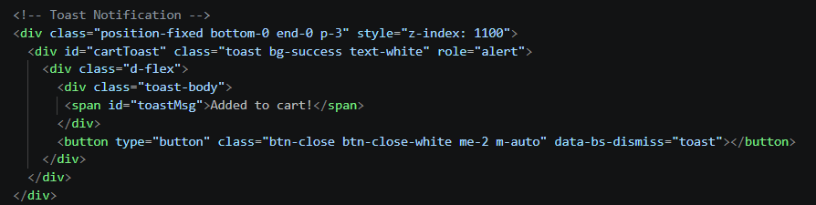 | Changed the toast appearance from the default to a green success message and added dynamic product names to the toast message | When the user clicks "Add to Cart" inside the modal popup, this toast notification slides up from the bottom-right corner of the screen for 1.5 seconds, confirming that the product has been successfully added to the shopping cart.

